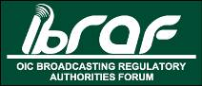
PERMANENT SECRETARIAT

MEETING MINUTES
Subject: | IBRAF Steering Committee Meeting (SCM)
Date and Place: | Jeddah, Saudi Arabia, 18-19 June 2014
Participants: | 1-Assoc. Prof. Dr. Hamit ERSOY –IBRAF Secretary General  2-Dr. Mehmet ÇAKIRTAŞ –IBRAF PS, Head of International Relations  3- Dr. Riyadh K. NAJM -preceding term-President, President of GCAM  4- A. Faheem Khalifa -Advisor, GCAM  5- Dr. Lemrini ALOUAHABI - Term-President, President of HACA  6-Amin Azziman -Expert, Int. Rel. Dept., HACA  7- Huweydi -OIC Information Department  -Dr. Seyed M. Hosseini - Forth. President, Head of Int. Rels.IRIB (absent)  -Mir Mousa M. Tarki -Director General for Contracts, IRIB (absent)  -Hamidreza Dehghani -AMB&Permanent Repr. of Iran to the OIC (absent)
To: | Secretary General of IBRAF
From: | - IBRAF PS
Distribution: | - Members of IBRAF Steering Committee
Annexes: | - Annex IBRAF Steering Committee Agenda
Pages: | 7 Pages (including annex)
Submission Date: | 30 June 2014
Executive Summary | OIC Broadcasting Regulatory Authorities Forum (IBRAF) Steering Committee Meeting (SCM) was held in the OIC HQs in Jeddah, Kingdom of Saudi Arabia on 18-19 June 2014 with the participation from IBRAF PS, HACA of Morocco as IBRAF term-President and GCAM of Kingdom of Saudi Arabia as IBRAF preceding term-President. Sadly neither participation from IRIB as initially confirmed was secured nor Mr. Hamidreza Dehghani, the Ambassador and Permanent Representative of Islamic Republic of Iran to the OIC was present as lately confirmed. Nonetheless, the SCM was held as scheduled and produced crucial results as detailed below. Meanwhile, the Television and Radio premises were visited and SCM participants were briefed about the broadcast in the Kingdom.

IBRAF SCM MINUTES
18-19 June 2014, Jeddah, Kingdom of Saudi Arabia

As briefly stated at the Executive Summary, OIC Broadcasting Regulatory Authorities Forum (IBRAF) Steering Committee Meeting (SCM) was held in the OIC HQs in Jeddah, Kingdom of Saudi Arabia on 18-19 June 2014 with the participation from IBRAF PS, HACA of Morocco as IBRAF term-President and GCAM of Kingdom of Saudi Arabia as IBRAF Preceding term-President. The meeting was held at the OIC Building, 10th floor Meeting Hall.

The President of the High Authority for Audiovisual Communication (HACA) of Morocco, Dr. Amina Lemrini ELOUAHABI, IBRAF term-President, delivered a statement in which she welcomed the participants, stating that she was honored by their presence in Jeddah to participate in the IBRAF SCM and in which she expressed gratitude to the Kingdom of Saudi Arabia for hosting the Meeting.

The representative of the Kingdom of Saudi Arabia, host of the meeting, Dr. Riyadh Kamal NAJM, the President of the General Commission for Audiovisual Media (GCAM) and IBRAF preceding term-President, delivered a statement in which he welcomed the participants to Jeddah, stating that he was honored by their presence in the Kingdom to participate in the meeting.

IBRAF Secretary General, Assoc. Prof. Dr. Hamit ERSOY, member of the Radio and Television Supreme Council (RTUK), delivered a statement in which he thanked the Kingdom of Saudi Arabia for hosting the SCM, and to the OIC General Secretariat, represented by its Information Department, for the contributions and support provided.

The Committee adopted the draft Agenda (Annexed).

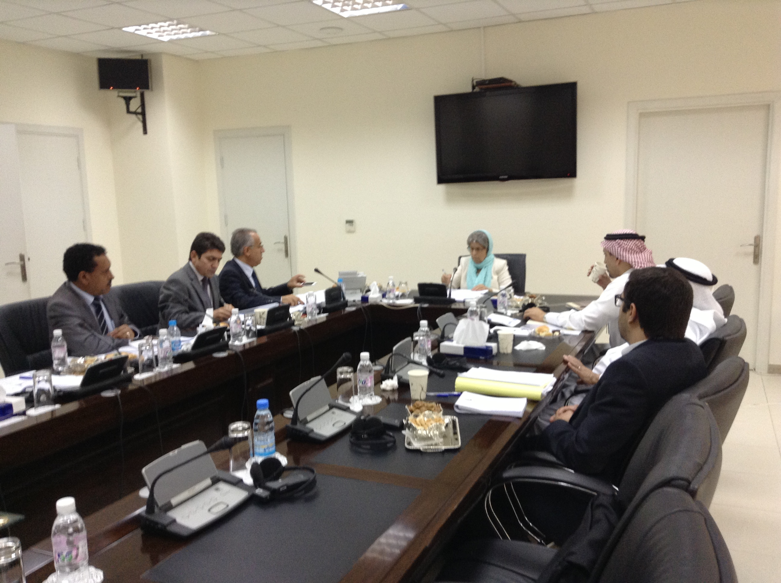
IBRAF SCM, OIC HQs, Jeddah

The following conclusions were made at the end of discussions at the meeting;
- Amendments to the Charter;
  - Any proposal for the amendment to the IBRAF Charter should be conveyed to the IBRAF PS who will forward it to the Steering Committee (SC). SC will decide to put the proposals on the agenda of the Annual Meetings.
  - Proposals for the amendment to the IBRAF Charter should be examined by the SC, annually. But these proposals should be put on the agenda of the Annual Meetings, once every three years.
- Proposals for the amendment to the IBRAF Charter, if any, will be put on the agenda of the 2015 Annual Meeting for the first time. For this purpose, a form will be uploaded to the IBRAF website.
- SC authorized the IBRAF PS to transfer the responsibility of “inventorying and contacting with the audiovisual regulatory authorities in the OIC Asian Region” (Action Plan Item-3) to preferably Malaysia, Indonesia or Pakistan, after warning the IRIB one last time.
- It is agreed that each member will present its Annual Progress Report for five minutes within every Annual Meeting.
- In the Annual Meetings, preceding term-Presidents will present an Annual Report of IBRAF activities.
- In the Annual Meetings, Panel Discussions should be organized with the experts on the specific issues.
- It is agreed to prepare a leaflet of IBRAF in all official languages of OIC, namely in English, French and Arabic. IBRAF PS, HACA and GCAM are responsible for these languages, respectively. It is also noted that IBRAF can be active in social media like Facebook or Twitter.
- It is decided that RTUK, HACA and GCAM will be responsible for the preparation and translation of the content for IBRAF website in English, French and Arabic languages, respectively. IBRAF PS will upload all the content.
- It is agreed that all the preceding term-Presidents will automatically be a member of SC.
- The date and place of the SC Meetings will be decided by term-President together with the IBRAF PS.
- SC authorized the IBRAF PS on determination of the date (within the second half of the December) and place of 2014 Annual Meeting.
- “Public Media Service and Broadcasting Principles” is the main theme of the 2014 Annual Meeting.
- It is agreed to warn IRIB one last time, whether they are committed or not to host the 2014 Annual Meeting.
- It is decided to request from OIC General Secretariat to designate an OIC Contact Point for IBRAF
At the end of the meeting, all these decisions abovementioned are approved by the participants.
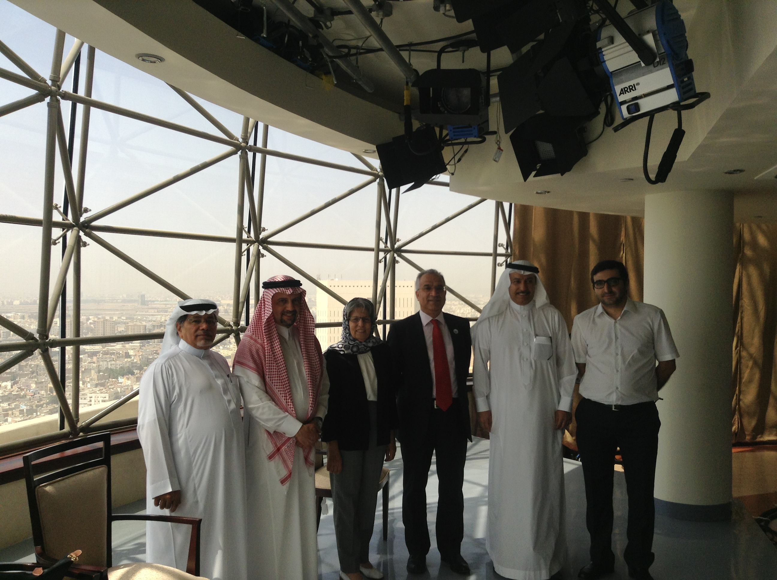
Jeddah Transmitter Tower
Following the visit to the Jeddah TV and Radio premises, the delegations were escorted to the hotel for departure.

Assoc. Prof. Dr. Hamit ERSOY
Secretary General of IBRAF

